Oracle Database Administration Services
Uninstallation Of Oracle Database

Submitted to



By



CIS, Wipro Limited

Document Details

Project Name | RWE Npower
Account | CIS
IT Component/Application Title | Uninstallation of Oracle Database
Current Version | 1.5
List of Contributors | Chetan Patel, Saurabh Nigam, JitenKumar Pansara Sreya Puthukudy
Customer Contact Information

Version History
(All revisions made to this document must be listed in chronological order. All revisions must be approved. Review and Approval can be done by an internal source or by the customer)

Version | Date of Revision | Description | Author | Reviewed By | Approved By
1.0 | 16-05-2015 | Intial Draft | Chetan Patel | Chetan Patel | Mihir Gajjar
1.1 | 22-08-2016 | Document Completed | Chetan Patel | Saurabh Nigam | Mihir Gajjar
1.2 | 23-09-2016 | Updated document to standard format | JitenKumar Pansara | JitenKumar pansara | Mahesh Keshatwar
1.3 | 17-05-2017 | Wipro and Innogy Logo changed | Sreya Puthukudy | JitenKumar pansara | Mahesh Keshatwar
1.4 | 31-10-2017 | Updated document to Wipro Standard format with header and footer | Sreya Puthukudy | JitenKumar pansara | Mahesh Keshatwar
1.5 | 30-12-2018 | Updated the content | Sreya Puthukudy | JitenKumar pansara | Santosh Badiger

Document Distribution List
S.No | Name and Company | Purpose
1 | RWEIT-ORACLEDBA | This document is about uninstallation of database
2

TABLE OF CONTENT
1. Purpose 5
2. Scope 5
3. Uninstallation Of Oracle Database 5
4. Reference 10

Purpose
This document is prepared for the concept of Un-Installation of Oracle Database at <Customer Name>.

Scope
This document is prepared for GSMC Wipro sustenance team and provides the concepts of Un-Installation of Oracle Database at <Customer Name>.

Uninstallation of Oracle Database

Step 1: Logon to DB Server.
Go to START ->RUN -> MSTSC
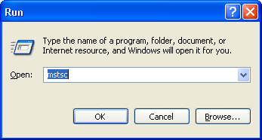

Step 2: Give the IP and press enter

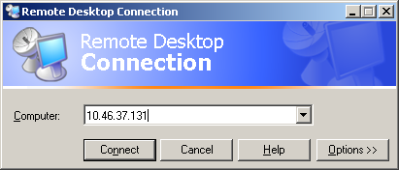

Step 3: Login with Group id and Right click on My Computer and select manage.
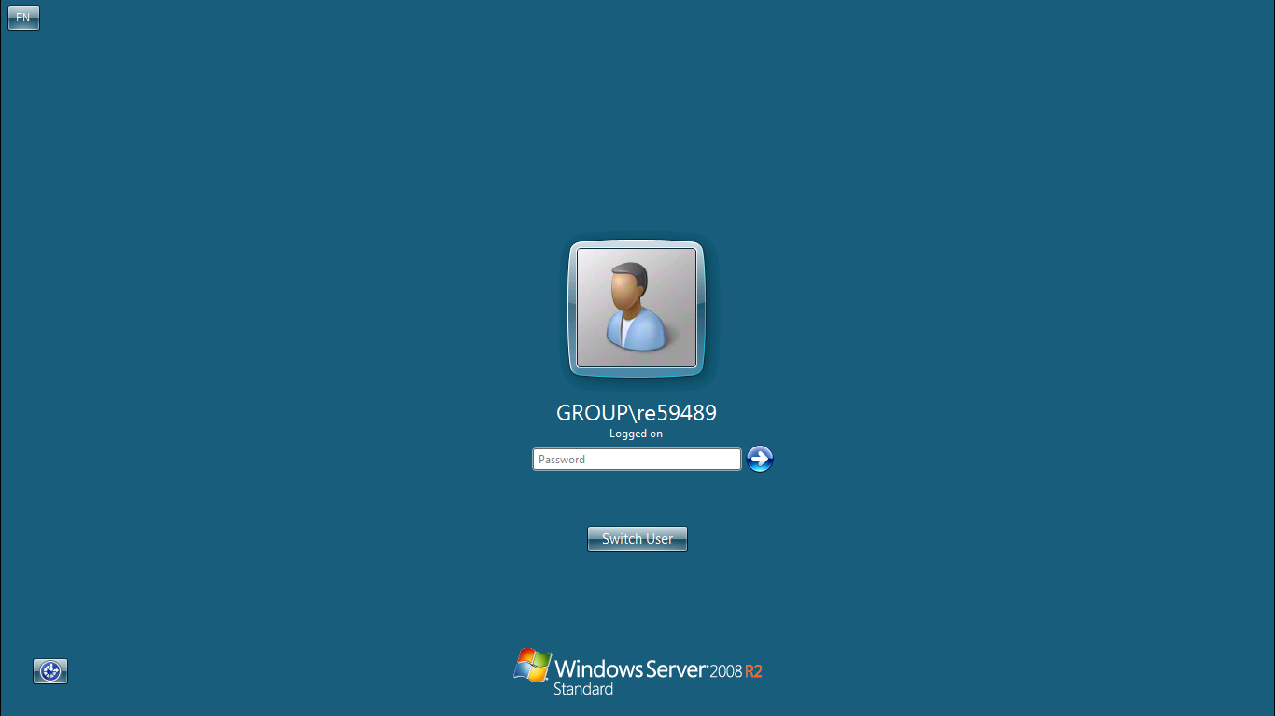
Step 4: Go to the below location

Start → Programs → Oracle10g → Oracle Installation Products → Universal Installer

Step 5: It will open prepare to launch OUI window.
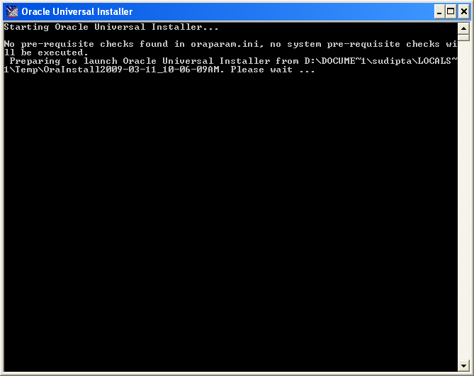
Step 6: Click on Deinstall Products.
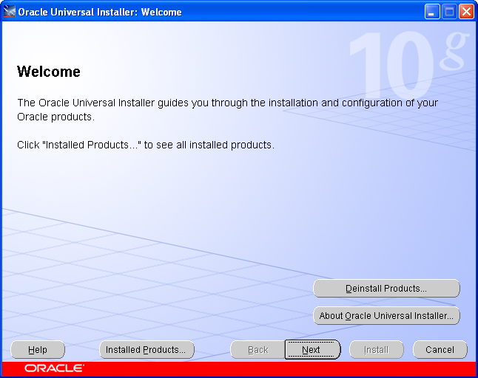

Step 7: Click on the Products you want to install and then click Remove
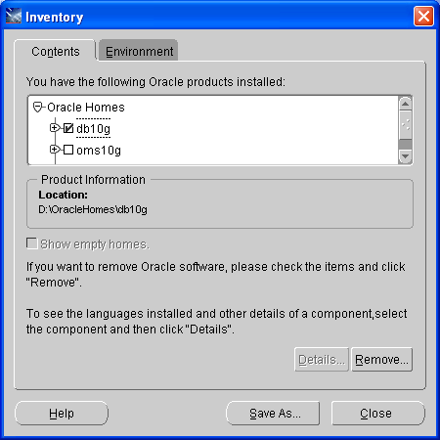
Step 8: On the confirmation screen click "Yes"
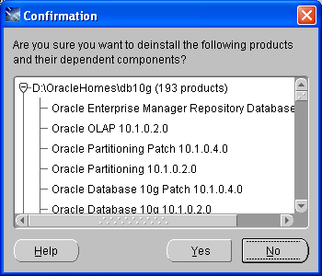

Step 9: When it has finished click "Close" and then "Exit" to quit the installer
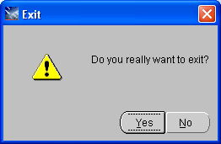

Reference
- http://www.cryer.co.uk/brian/oracle/howto_uninstall_oracle9i.htm

